WINTER SEMESTER 2025-26

BCSE203E: Web Programming

Lab 3
Date: 12/12/2025

Reg. No: 24BCE5362

VIT LOGO

CODE:

<!DOCTYPEhtml>
<html>
<head>
<title> Image Map Image Sample </title>
</head>
<body>
<h1> 24BCE5362 </h1>
<h1> Balashanmugam K </h1>
<img src="logo.jpg" alt="VIT Campus Login" usemap="#mymap">
<map name="mymap">
<area shape="rect" coords="40,122,125,112" href="https://vit.ac.in/" target="_blank">
<area shape="rect" coords="176,125,256,112" href="https://chennai.vit.ac.in/" target="_blank">
</map>
</body>
</html>
Output:
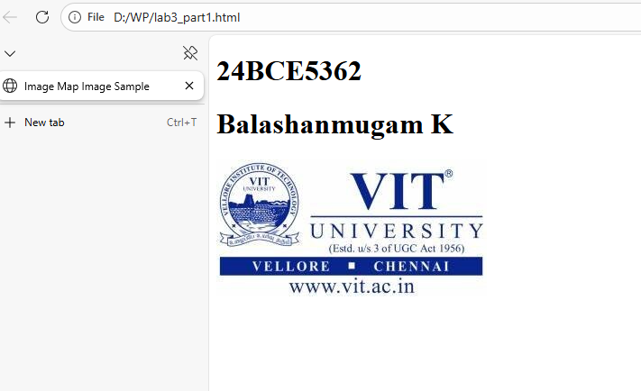

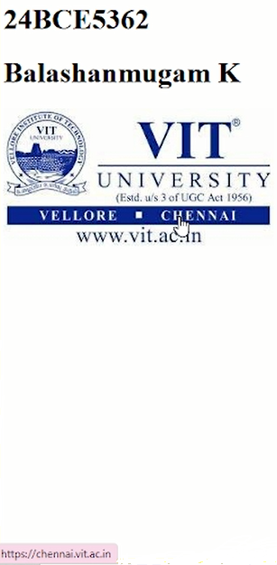
Table
CODE:
<!DOCTYPEhtml>
<html>
<head>
<title> Table </title>
<style>
table {
width: 65%;
}
th, td {
border: 1px solid black;
padding: 8px;
}
</style>
</head>
<body>
<h1>24BCE5362</h1>
<h1>Balashanmugam K</h1>
<table border="1">
<tr><th colspan="10">TIME TABLE</th></tr>
<tr>
<td><p style="text-align: center;"><b><b>Day/Period</b></p></td>
<td><p style="text-align: center;"><b>I<br>9:30-<br>10:20</b></p></td>
<td><p style="text-align: center;"><b>II<br>10:20-<br>11:10</b></p></td>
<td><p style="text-align: center;"><b>III<br>12:00-<br>12:40</b></p></td>
<td><p style="text-align: center;"><b>12:00-<br>12:40</b></p></td>
<td><p style="text-align: center;"><b>IV<br>12:40-<br>1:30</b></p></td>
<td><p style="text-align: center;"><b>V<br>1:30-<br>2:20</b></p></td>
<td><p style="text-align: center;"><b>VI<br>2:20-<br>3:10</b></p></td>
<td><p style="text-align: center;"><b>VII<br>3:10-<br>4:00</b></p></td>
</tr>
<tr>
<td>Monday</td>
<td>Eng</td>
<td>Mat</td>
<td>Che</td>
<td rowspan="5">LUNCH</td>
<td colspan="3">LAB</td>
<td>Phy</td>
</tr>
<tr>
<td>Tuesday</td>
<td colspan="3">LAB</td>
<td>Eng</td>
<td>Che</td>
<td>Mat</td>
<td>SPORTS</td>
</tr>
<tr>
<td>Wednesday</td>
<td>Mat</td>
<td>Phy</td>
<td>Eng</td>
<td>Che</td>
<td colspan="3">LIBRARY</td>
</tr>
<tr>
<td>Thursday</td>
<td>Phy</td>
<td>Eng</td>
<td>Che</td>
<td colspan="3">LAB</td>
<td>Mat</td>
</tr>
<tr>
<td>Friday</td>
<td>Phy</td>
<td>Eng</td>
<td>Che</td>
<td colspan="3">LAB</td>
<td>Mat</td>
</tr>
</table>
</body>
</html>

Output:
